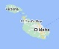
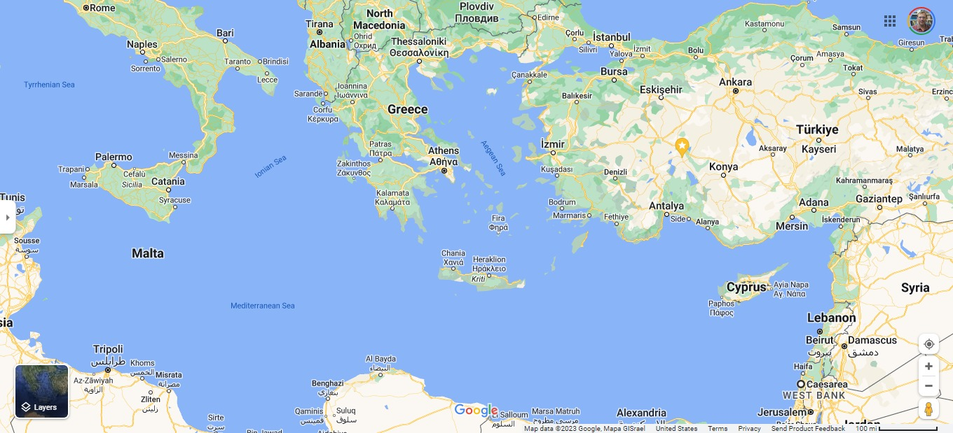
APPENDIX: Paul’s 1st Trip To Rome In V Parts Under Roman Escort
Part IVab
Part IIIabc
Part IIabc
Part Vab
Part I

Part I
The Sea Voyage From Caesarea Maritima
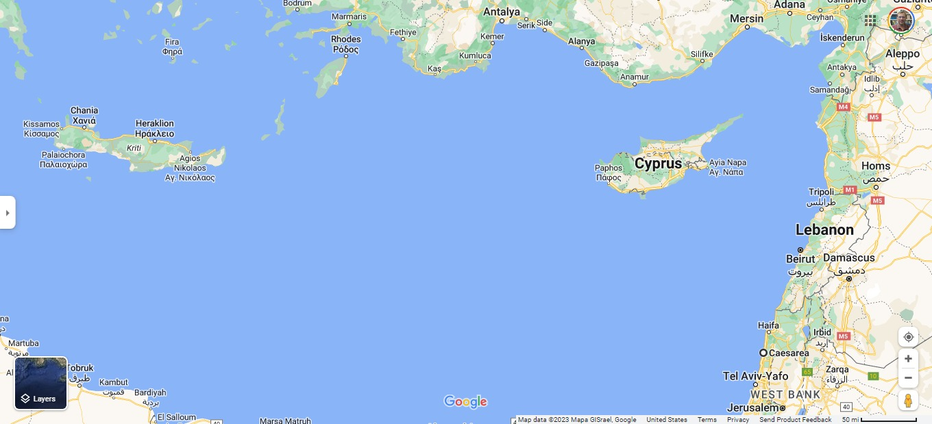
To Fair Havens / Lasaea On Crete
Fair Havens
Salome
Rhodes
Cnidus
Sidon
Tyre
Myra
Caesarea Maritima
Part I

Part IIabc ^{Sea}
The Sea Voyage From Fair Havens / Lasaea On Crete
To Shipwreck on the Island of Malta

Part IIabc
Syracuse
Malta
Phoenix

Fair
Havens
Cuada

Cyrene
Greater Syrtis
Region of Libya

Part IVa
Sea Passage From the Island of Malta
To Syracuse On the Island of Sicily

Part IVa

Syracuse
Malta
Part IIIabc
See Below

Part IVb
Sea Passage From Syracuse On the Island of Sicily
To the Shores of the Mailand of Italy at Rhegium

Part IVb

Rhegium

Syracuse

Part Va ^{Sea}
Sea Journey From Rhegium To Puteoli

Puteoli

Part Va
By Sea

Rhegium

Part Vb ^{Land}
The Roads From Puteoli To Rome
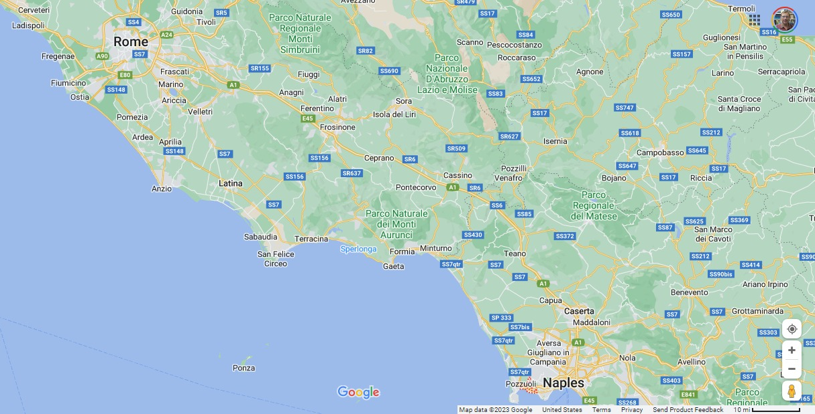
Via the Appian Way with Stops in Appii Forum & Tres Tabernae
Part Vb
By Land
Tres
Tabernae
Puteoli
Appii
Forum
Appian
Way

Part III Washed Ashore on the Island of Malta

Malta

Part IIIa Shoreline On Malta & Paul’s Shipwreck Site
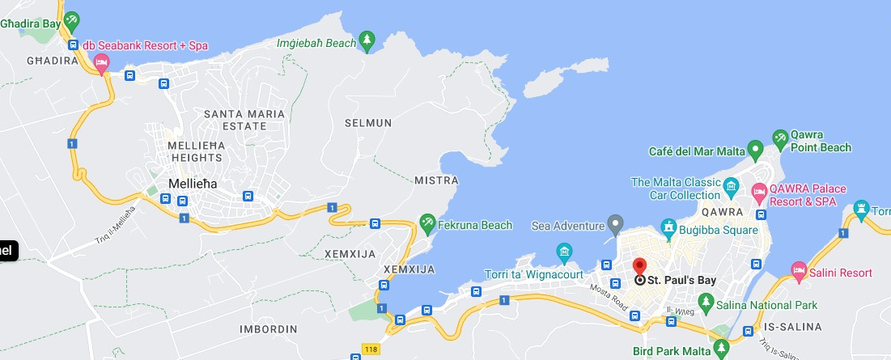
Washed Ashore Site
St. Paul’s Island
& Wreck Site
St. Paul’s Bay

Part IIIb Close Up of Paul’s Traditional Shipwreck & Washed Ashore Sites
Washed Ashore Site
St. Paul’s Island
& Wreck Site
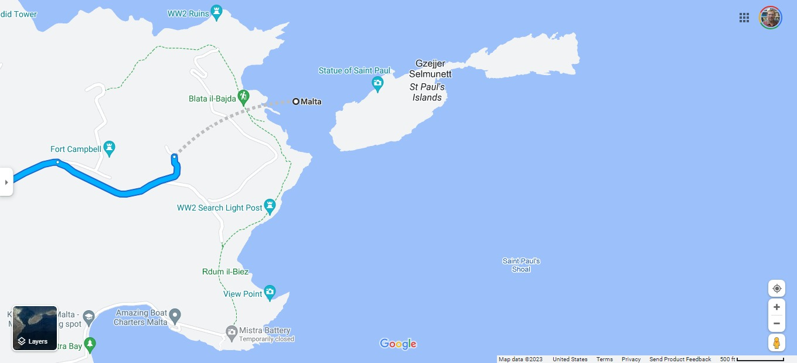

Part IIIc – St. Publius’ Estate &
St. Paul’s Cathedral In Mdina, Malta
San Pawl Milqi – St. Publius’ Estate
St. Paul’s Church / Cathedral
Washed Ashore
Site
St. Paul’s Island
& Wreck Site

Lesser Syrtis & Greater Syrtis (Quick Sands)
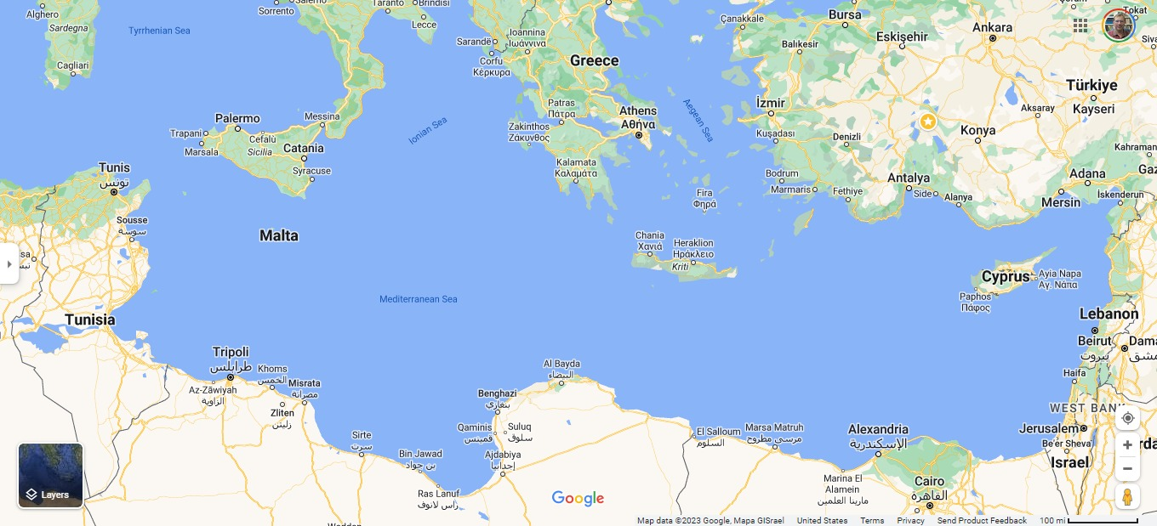
In the Gulf of Gabes, Tunisia To Gulf of Sidra & Cyrene, Libya
Crete
Greater Syrtis Region of Libya
Lesser Syrtis Region of Tunisia

